**What is generic components of system and What is system configuration ?**

Gathering details about below generic components of system should help to create picture or diagram of overall system configuration. Details of generic components are building blocks to create a overall system configuration.

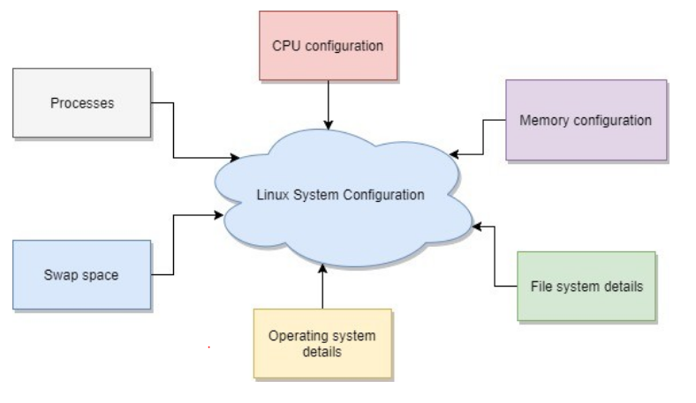

Below are generic components.

1. Number of CPU and type of it.
2. Available memory on server.
3. File system and partition,
4. Operating system related details.
5. Swap space.
6. Processes running on system.
7. Other components. ( *Inputs are welcome*).

Next question would be to how to find out details about each of component. Below section address that.

**How to find out details about generic component of system ?**

There can be multiple ways or commands to find out details about each of generic component. Trying to describe some of basic methods and commands. There could be more methods or commands using which same result or better results can found out. ( *Inputs are welcome* )

* Number of CPU and type of it.

"cat /proc/cpuinfo"

* Available memory on server.

"cat /proc/meminfo"

* File system and partition,

"cat /etc/fstab"

* Operating system related details.

"uname -a"

* Swap space.

"df -h | grep swap"

* Processes running on system.

"ps -aux"

Note : One can find out more details about specific linux command by using "manual" command in Linux. Example - "man uname" command will give details about all the arguments available to "uname" command and how output can be formatted.

"man uname"

Details gathered about generic component of system will give basic details about system configuration.

For example : Sample output of each of above command for a component can be put in a table format to create system configuration document. Or it can be put in a diagram.

There are more complex components ( Example : Cache memory ) or hardware of Linux system ( Network card ) which is installed in system and details about this complex component can help to create detailed diagram or overall picture of system configuration. Will try to cover details about this components in next article.

All product names , logos and company names used in this article are trademarks of respective product and company.